Transition Questionnaire

Use this to map out what “success” looks like for you and get your thoughts on paper

Desired Outcome:

Questions:
What is your timeline for retirement?

What are your financial needs from the farm in retirement and how would you like a buyout or transition to be structured? i.e. timing and length of payments

What other benefits would you like to receive from the farm business in retirement?
i.e. shop lease payments, health insurance

What role would you like to have in the farm business in transition or retirement?

What does a win-win buyout or transition proposal look like to you?

What is your goal in farm transition and what do you hope to gain from it?

Do you support the business model we are proposing or how could it be improved?

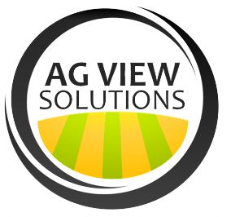
What questions do you have for us?

